
Green University of Bangladesh
Department of Computer Science and Engineering(CSE)
Faculty of Sciences and Engineering
Semester: (Spring, Year:2024), B.Sc. in CSE (Day)

LAB REPORT NO #03
Course Title: Database Lab
Course Code: CSE 210 Section: 221_D9

Experiment Name: Modifying MySQL databases and Updating Data in
MySQL Table

Student Details

Name |  | ID
1. | Jahidul Islam | 221002504

Lab Date : 09 – 03 – 2024
Submission Date : 16 – 03 – 2024
Course Teacher’s Name : Md. Nazmus Shakib

[For Teachers use only: Don’t Write Anything inside this box]

Lab Report Status
Marks: ………………………………… Signature:.....................
Comments:.............................................. Date:..............................

1. TITLE OF THE LAB EXPERIMENT:

Modifying MySQL databases and Updating Data in MySQL Table

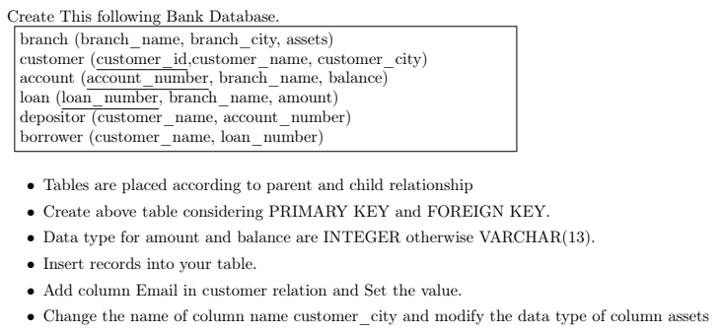

2. OBJECTIVES:

After complementing this lab experiment, we will gain practical knowledge and the outcomes of this experiment are

- To gain the advance knowledge for modifying and updating MySQL databases.

3. PROCEDURE:

To successfully complete the outcomes, we have done the following.
- Database Design:
Database Name: Bank, consisting of 6 tables.
- Table Cration:
  - Branch has one primary key.

  - customer has 1 primary key: customer_id

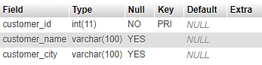

  - account has 1 primary key
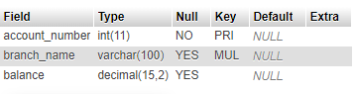

  - borrower table has 2 columns.
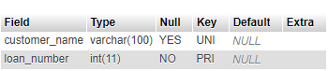

  - loan with 3 columns and 1 primary key
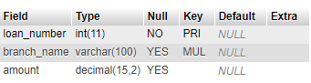

4. IMPLEMENTATION

Here’s I have included all the code we need to obtain all the outcomes of this experiment.
Codes:
CREATE DATABASE bank;
use bank;
Now we need to create 6 tables: branch, customer, account, loan, depositor, borrower.

Table creation:

CREATE TABLE branch(branch_name VARCHAR(100),branch_city VARCHAR(100),assets DECIMAL(15, 2),PRIMARY KEY(branch_name)
);
CREATE TABLE customer(customer_id INT PRIMARY KEY,customer_name VARCHAR(100),customer_city VARCHAR(100)
);
CREATE TABLE ACCOUNT(account_number INT PRIMARY KEY,branch_name VARCHAR(100),balance DECIMAL(15, 2),FOREIGN KEY(branch_name) REFERENCES branch(branch_name)
);
CREATE TABLE loan(loan_number INT PRIMARY KEY,branch_name VARCHAR(100),amount DECIMAL(15, 2),FOREIGN KEY(branch_name) REFERENCES branch(branch_name)
);
CREATE TABLE depositor(customer_name VARCHAR(100),account_number INT,
FOREIGN KEY(customer_name) REFERENCES customer(customer_name),
FOREIGN KEY(account_number) REFERENCES ACCOUNT(account_number)
);
CREATE TABLE borrower(customer_name VARCHAR(100),loan_number INT,
FOREIGN KEY(customer_name) REFERENCES customer(customer_name),
FOREIGN KEY(loan_number) REFERENCES loan(loan_number)
);

- Insertion in the table:
  - Branch Table:
INSERT INTO branch (branch_name, branch_city, assets) VALUES
('Dhaka Branch', 'Dhaka', 1000000.00),
('Chittagong Branch', 'Chittagong', 1500000.50),
('Sylhet Branch', 'Sylhet', 2000000.75),
('Khulna Branch', 'Khulna', 1200000.25),
('Rajshahi Branch', 'Rajshahi', 1800000.80),
('Barisal Branch', 'Barisal', 2200000.90);

  - Account Table:
INSERT INTO account (account_number, branch_name, balance) VALUES
(1001, 'Dhaka Branch', 50000.00),
(1002, 'Chittagong Branch', 75000.50),
(1003, 'Sylhet Branch', 100000.75),
(1004, 'Khulna Branch', 60000.25),
(1005, 'Rajshahi Branch', 90000.80),
(1006, 'Barisal Branch', 110000.90);
  - Customer Table:
INSERT INTO customer (customer_id, customer_name, customer_city) VALUES
(1, 'Mohammad Rahman', 'Dhaka'),
(2, 'Fatima Begum', 'Chittagong'),
(3, 'Abdul Ali', 'Sylhet'),
(4, 'Nusrat Jahan', 'Khulna'),
(5, 'Hasan Ahmed', 'Rajshahi'),
(6, 'Ayesha Khan', 'Barisal');

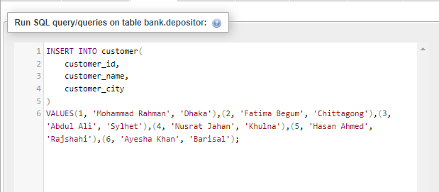

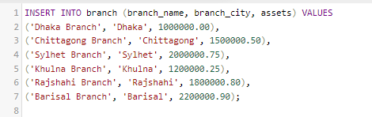

  - borrower table:
INSERT INTO borrower (customer_name, loan_number) VALUES
('Mohammad Rahman', 10001),
('Fatima Begum', 10002),
('Abdul Ali', 10003),
('Nusrat Jahan', 10004),
('Hasan Ahmed', 10005),
('Ayesha Khan', 10006);

  - loan table:

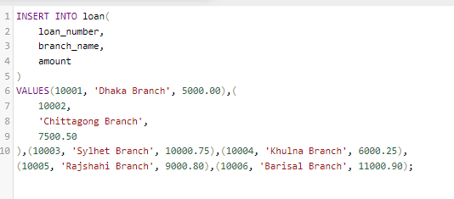

- Modifying exiting table.
  - Add column Email in customer table.

  - Change customer_city to address
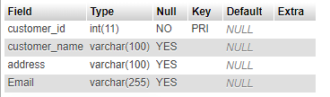

  - Modified assets column to DECIMAL with two-point float position.

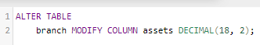

5. OUTPUT:

We can see the data of our earlier created database uing the following command.
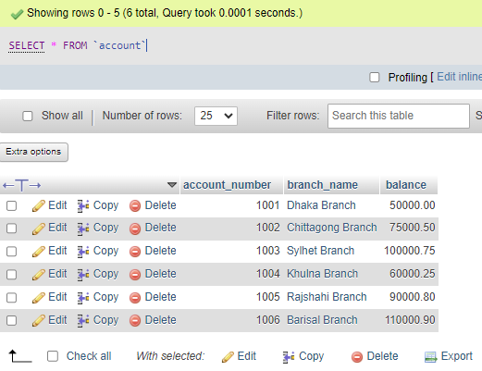

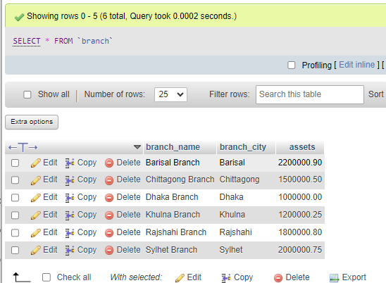

6. ANALYSIS AND DISCUSSION:

7. SUMMARY:

The lab experiment is successfully completed on creating and inserting data in the database with the given Lab Task.
The data insertion has reference integrity by referencing existing data from another tables. The lab aimed to demonstrate the implementation of integrity constraints and foreign key relationships in MySQL databases while updating existing tables and data in it.

Data types are chosen differently, with DECIMAL though the given instruction was to choose INTEGER type for numerical values like amount and balance, and VARCHAR for textual data.

